MVC Rentals, LLC
1480 Glass Ave
Hopkinsville, KY 42240
(270) 707-0641
info@michaelvancecontracting
One Time ACH Payment Authorization Form
Sign and complete this form to authorize MVC Rentals, LLC to make a one time ACH debit to your bank account.

By signing this form you give us permission to debit your account for the amount indicated on or after the indicated date. This is permission for a single transaction only, and does not provide authorization for any additional unrelated debits or credits to your account.

Please complete the information below:

I ____________________________ hereby authorize MVC Rentals, LLC to charge my bank account indicated below for $_____________ on or after ___________________.
(amount) (date)

Billing Address ____________________________ Phone# ________________________
City, State, Zip ____________________________ Email ________________________

Account Type: Checking Savings
Name on Acct _______________________________
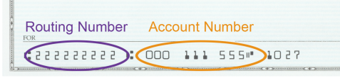
Bank Name _______________________________
Account Number _______________________________
Bank Routing # _______________________________
Bank City/State _______________________________

SIGNATURE DATE

I understand that because this is an electronic transaction, these funds may be withdrawn from my account as soon as the above noted periodic transaction dates. In the case of an ACH Transaction being rejected for Non-Sufficient Funds (NSF) I understand that MVC Rentals, LLC may at its discretion attempt to process the charge again within 30 days, and agree to an additional $50.00 charge for each attempt returned NSF which will be initiated as a separate transaction from the authorized recurring payment. I acknowledge that the origination of ACH transactions to my account must comply with the provisions of U.S. law. I agree not to dispute this recurring billing with my bank so long as the transactions correspond to the terms indicated in this authorization form.

Please attach a voided check or deposit slip and return this form MVC Rentals, LLC

